**Quality Improvement Study**

**Measuring Learning Outcomes in Student Satisfaction Surveys**

**Spring 2013**

1. **Purpose of the Study**

The purpose of the study is to demonstrate that students who receive health services at any FAU campus clinic are able to articulate on the annual satisfaction survey at least one item they learned during their most recent clinic visit.

The satisfaction survey will be administered to at least 300 male/female students who utilized health services during 2012-2013. It will be accessible via computer or hard copy to all students upon the conclusion of their visit to the Boca, Jupiter and Davie clinics. A content specific learning outcome question is included in the SHS satisfaction survey.

The SHS ARNP/Coordinator and QMI Committee Chair will be responsible for data collection via the satisfaction survey tool. The QMI Committee will approve the survey question. The QMI Committee will request data collection to commence Fall 2012 and be completed by the end of Spring 2013. Hard copy surveys are scored by a Program Assistant; computer based surveys are scored by SHS IT staff.

1. **Performance Goal**

75% of students answering the SHS satisfaction survey learning outcome question will be able to identify one item they learned during the most recent clinic visit.

1. **Data to be Collected**

Participants answered this question on the student satisfaction survey:

During your most recent visit to Student Health Services, what did you learn about promoting your health, engaging in a healthy lifestyle or reducing your risk for diseases? (Please check all that apply)

* + Ways to prevent communicable diseases (e.g. upper respiratory infections, influenza, skin infections, etc.):
  + Knowledge about a specific diagnosis and treatment(s) for the diagnosis:
  + Knowledge about prescription medications and/or over-the-counter products:
  + Knowledge about promoting a healthy lifestyle (e.g. stress reduction, nutrition, exercise, smoking cessation, etc.):
  + Knowledge about immunizations:
  + How to promote healthy teeth and gums:
  + Ways to prevent sexually transmitted infections:
  + Knowledge about mental health issues:
  + If other, please specify:

1. **Evidence of Data Collection**

A total of 382 students participated in the annual student satisfaction survey.

1. On the Boca campus, 218 out of 276 students were able to articulate at least one item they learned on their most recent clinic visit. The most frequently chosen learning outcome was “Knowledge about a specific diagnosis and treatment(s) for the diagnosis”.
2. On the Broward campus, 49 out of 55 students were able to articulate at least one item they learned on the most recent clinic visit. The most frequently chosen learning outcome was “Knowledge about a specific diagnosis and treatment(s) for the diagnosis”.
3. On the Jupiter campus, 45 out of 51 students were able to articulate at least one item they learned on the most recent clinic visit. The most frequently chosen learning outcome was: “Knowledge about immunizations”.
4. **Analysis/Trends**
5. On the Boca campus, 79% of the students met the performance goal. This is a 3.3% increase over last year 2011-12.
6. On the Broward campus 89% of the students met the performance goal. This is a 11% decrease over last year 2011-12.
7. On the Jupiter campus, 88% of the students met the performance goal. This is a 12% decrease over last year 2011-12.

Boca Student Health Services

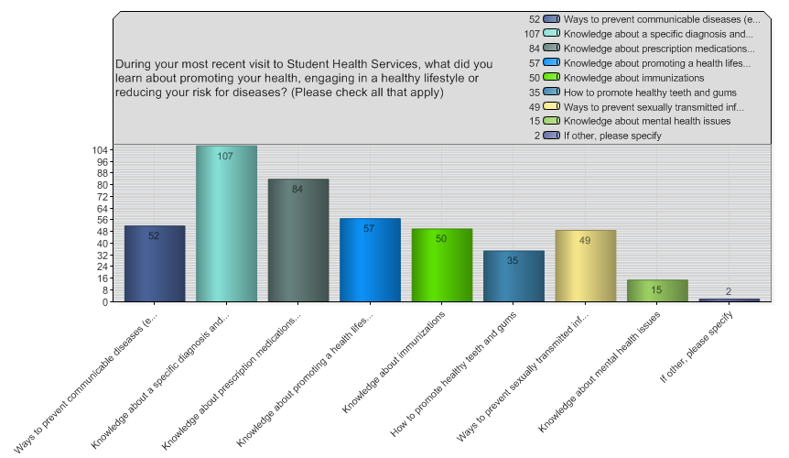

Broward Student Health Services:

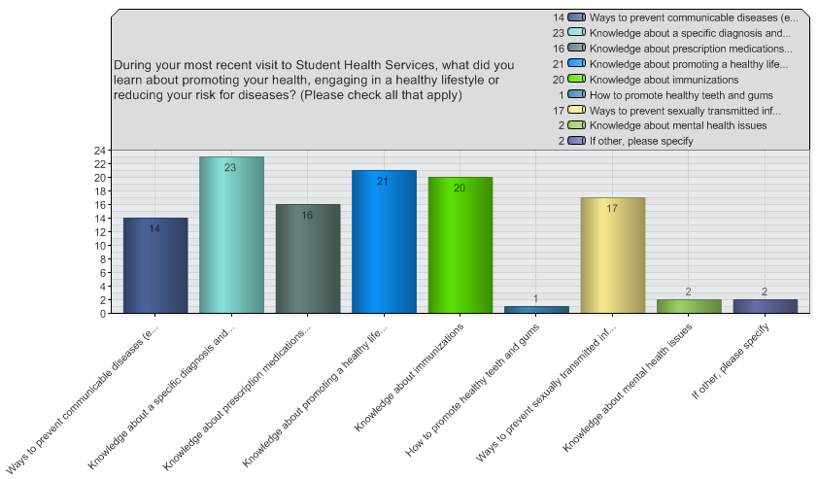

Jupiter Student Health Services

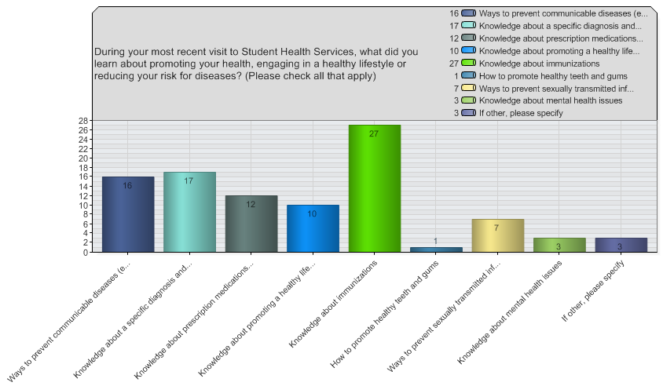

1. **Comparison of Current Performance vs. Goal**

Greater than 75% of students who responded in each of the three clinics were able to identify on the satisfaction survey, one item they learned during their most recent visit.

1. **Corrective Actions**

None indicated

1. **Re-Measurement**

Repeat annually for learning outcome assessment requirements.

**Recommendations**

1. Under list of choices of topics discussed to #9 specify “topics not listed”.

Plan:

1. Encourage all clinic staff to utilize handouts/brochures for specific diagnosis/topics when seeing students for clinic visits.

2. After each encounter, clinic staff should document patient education in the electronic health record via their SOAP note under "Plan". This will be assessed using peer review of clinic records each semester.

3. Re-survey students using the same learning outcome question during 2013-14 and compare success of criterion for three years (2011-12, 2012-13 and 2013-14), looking for trends.

1. **Reporting and Education**

Results will be shared with the SHS staff, QMI Committee, the Student Health Advisory Council, SHS Executive Committee, partner campus representatives and other FAU staff, as needed.

H:\Microsoft Word\General Documents\QMI Committee\QMI studies\Satisfaction Survey Learning Outcomes\2013 Satisfaction Survey Learning Outcomes 6.13.docx